TURESDVEN

LOADING Y 

O

UR RO

A GNI RA

The hum of your bike engine as you conquer Khardung La.

HOME LOCATIONS GALLERY ENQUIRY ABOUT US REV & 

REV &

ROAR

ROAR

Welcome to Rev & Roar! Conquer the Himalayas your way—on a bike,

in a tempo traveler, or with your crew. Adventure starts here!

Thrilling high-altitude passes with expert guides.

Location

Roaring Tour Packages

ENROLL NOW. R

W.

O

AR N WO

O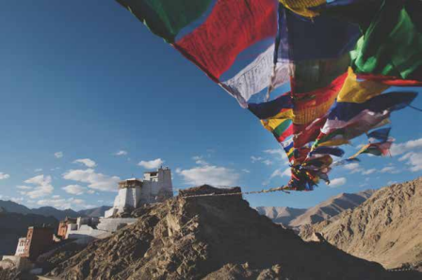RNE. LL NO

NOW.ENROLL NOW.

Ladakh

Date- 10th Jan- 21th Jan

Price- 30,900/-

CONTACT US

Ready to Rev & Roar? Let’s make it happen! • Call Us: +91 [Your Number]

• Email: info@revandroar.com

• WhatsApp: Tap the button below for instant queries.

ROAR 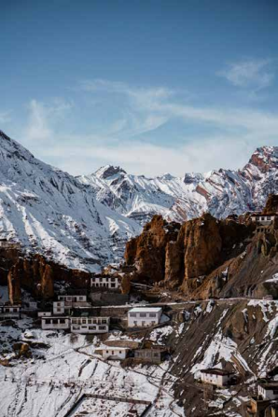

Spiti

Date- 21th Jan- 5th Fri

Price- 30,900/-

. WON

ENRO LL

Follow us on Instagram and Facebook to see what adventure looks like!

A shared laugh with friends under the starry skies of Spiti.

HOME LOCATIONS GALLERY ENQUIRY ABOUT US REV &

DESTINATIONS ROAR WE CALL HOME 

REV &

ROAR

ROLL NOW.

ENROLL

N

NOW. OR NRA

WO .E

LadakhThink Pangong Tso’s magical hues,

the thrill of KhardungLa, and the

warm smiles of Nubra Valley.

NOW.L

ROL

ENROLL NOW. ROAR

Spiti A remote wonderland with

NE. WON

crystal-clear skies, ancient

monasteries, and landscapes

that belong in a dream.

CONTACT US

Ready to Rev & Roar? Let’s make it happen!

• Call Us: +91 [Your Number]

• Email: info@revandroar.com

• WhatsApp: Tap the button below for instant queries. Follow us on Instagram and Facebook to see what adventure looks like!

HOME LOCATIONS GALLERY ENQUIRY ABOUT US REV & GALLERY ROAR

A Picture is Worth a Thousand Adventures

Explore our gallery featuring glowing sunsets over Pangong Lake, joyful group shots in Spiti, and the sheer thrill of biking through the Himalayas.

RE NOW.

ROARING T

R

S. LC OT KCI EXPLO PI 

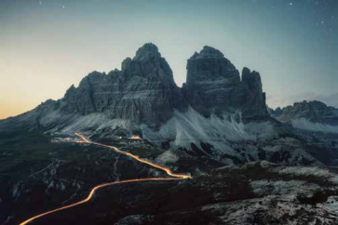Ladakh LLadakh Ladakh adakh LSpiti adakh

RE NOW.

ROARING T 

R

S. LC OT KCI EXPLO

PI

TESTIMONIALS

NEHA SHARMA LADA HK EKI B TR PI 

RAHUL KAPOOR

“This trip was the best decision of my life! Riding through Ladakh with Rev & Roar felt like living a dream. Their team made every moment unforgettable!”

LADA HK EKI B TR PI“As a corporate group, we were blown away by their professionalism and attention to detail. From tempo rides to adventure-packed days, every detail was perfect!” 

NEHA SHARMA LADA HK EKI B TR PI 

“This trip was the best decision of my life! Riding through Ladakh with Rev & Roar felt like living a dream. Their team made every moment unforgettable!”